**Task on Load Balancers.\***

1. Configure Classic Load balancer.*

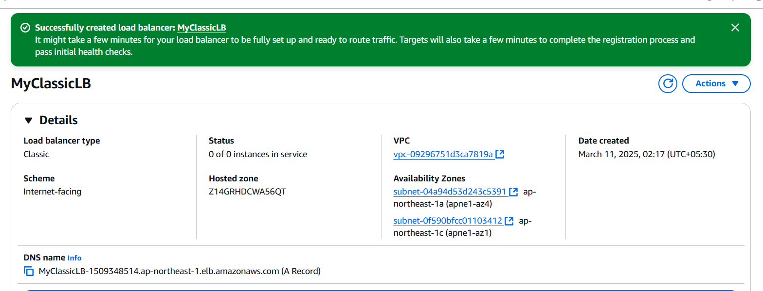

After refreshing the server will be changed ,server 01 and server02

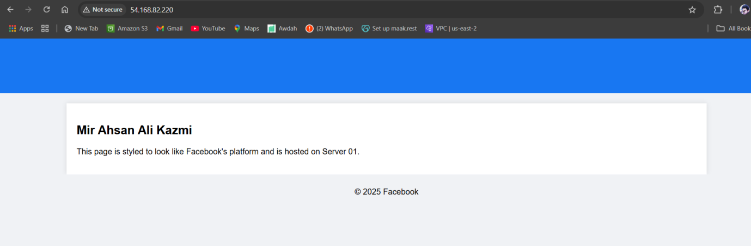

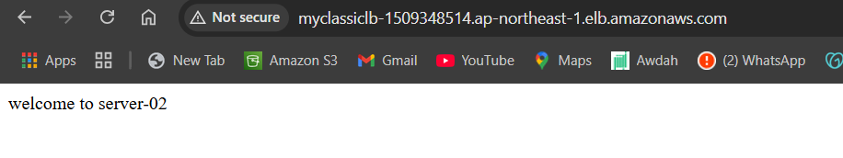

Launch ec2 and install http sever 02 by using script

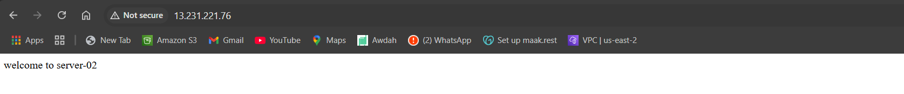

Lauch ec2 server 01 install httpd

Select as a target instances and registered

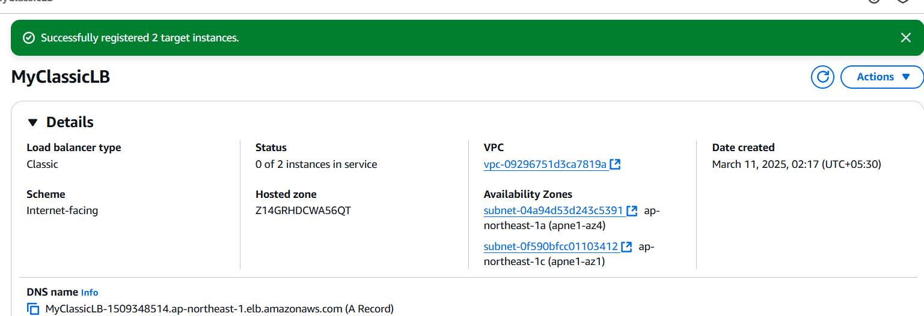

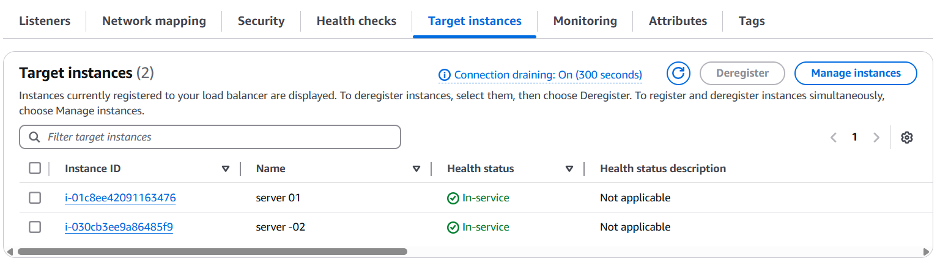

lauch

1. Configure Application Load balancer.* 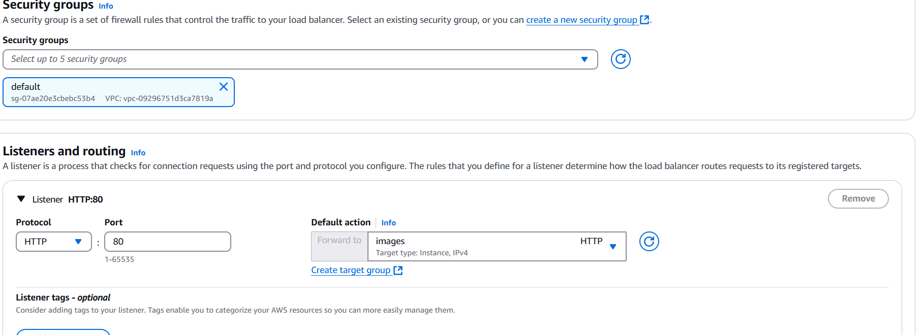

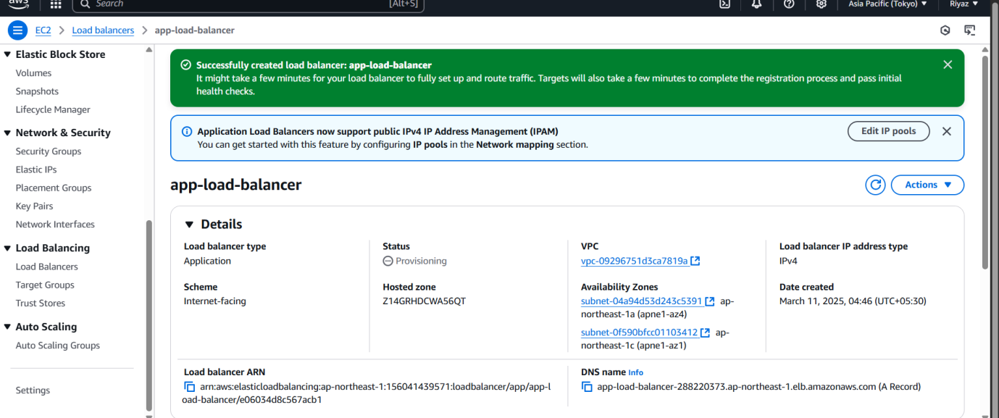

 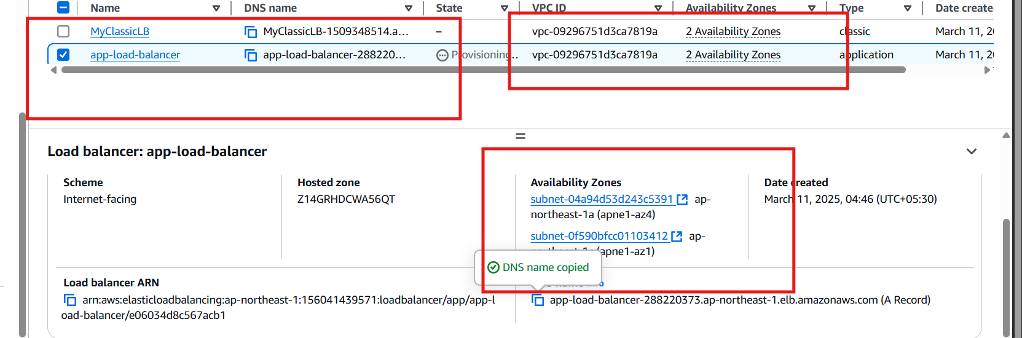

Add listerner and rule 1 and condition and path prefixes

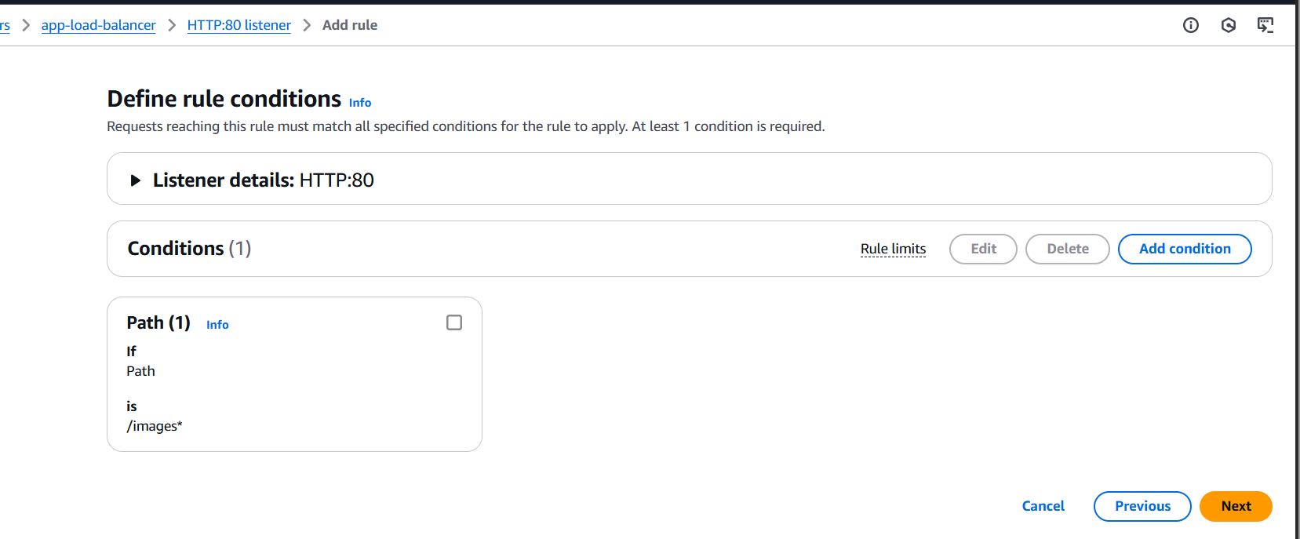

Is uses prefixes images

http://app-load-balancer-288220373.ap-northeast-1.elb.amazonaws.com/images/

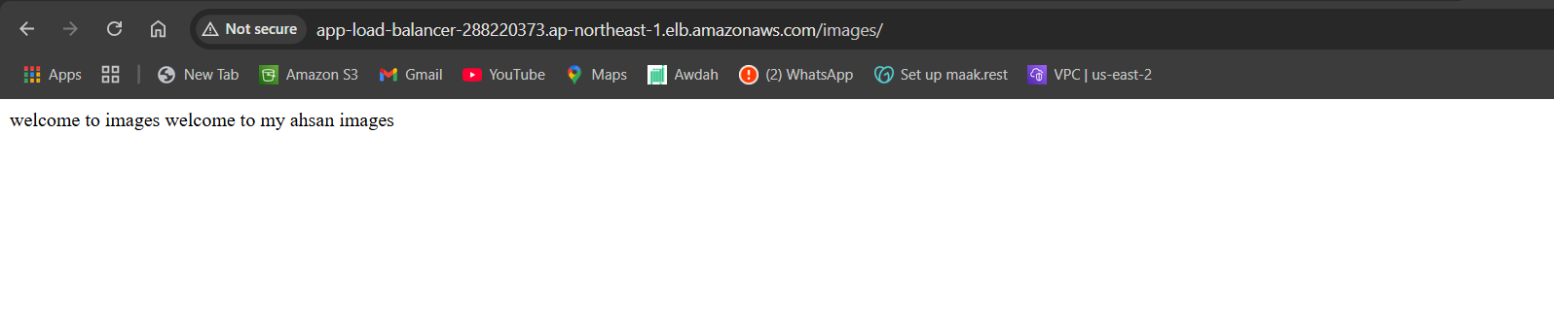

1. Configure Network Load balancer.*

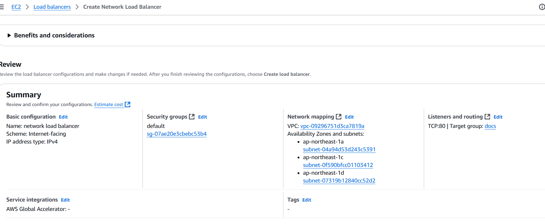

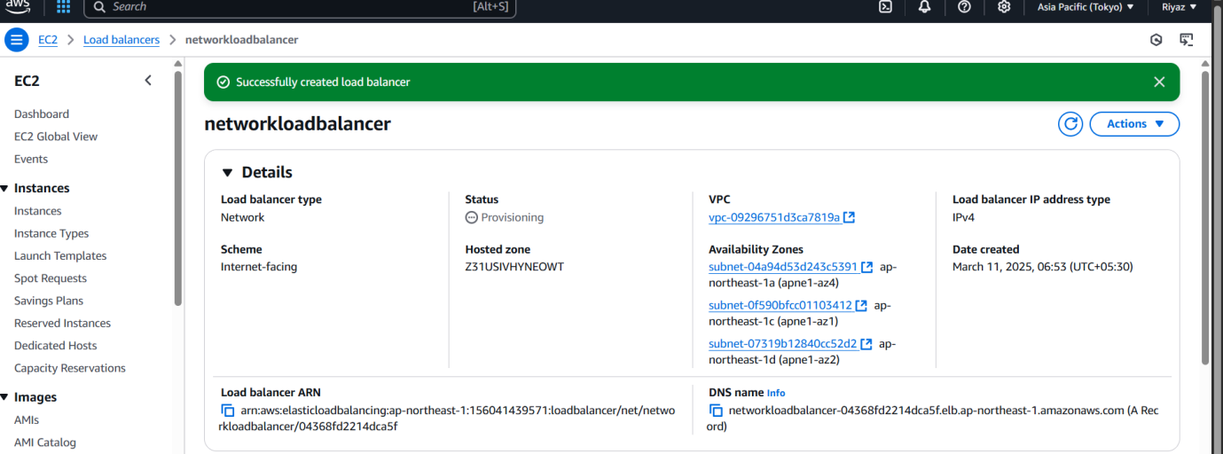

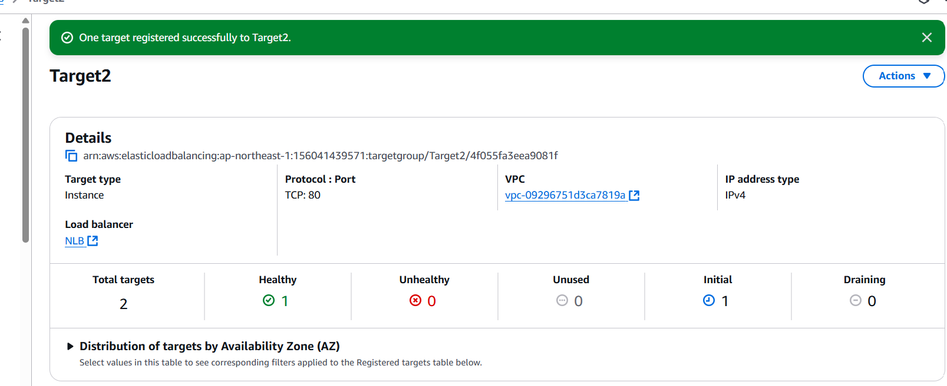

DNS NAME

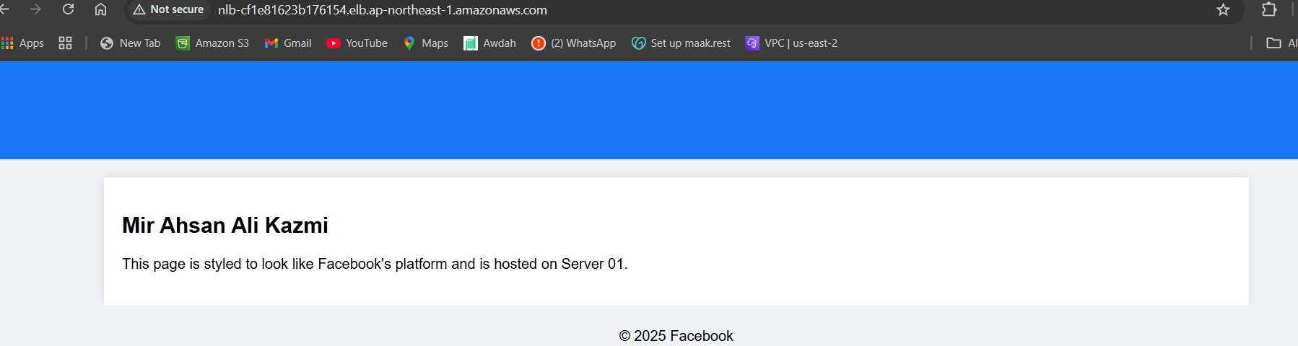

DNS NAME

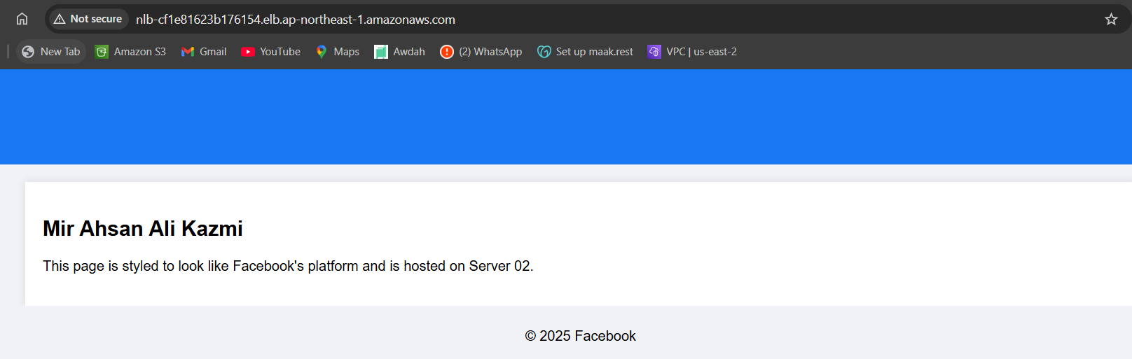

Registry target has been and ec2 in regester to target

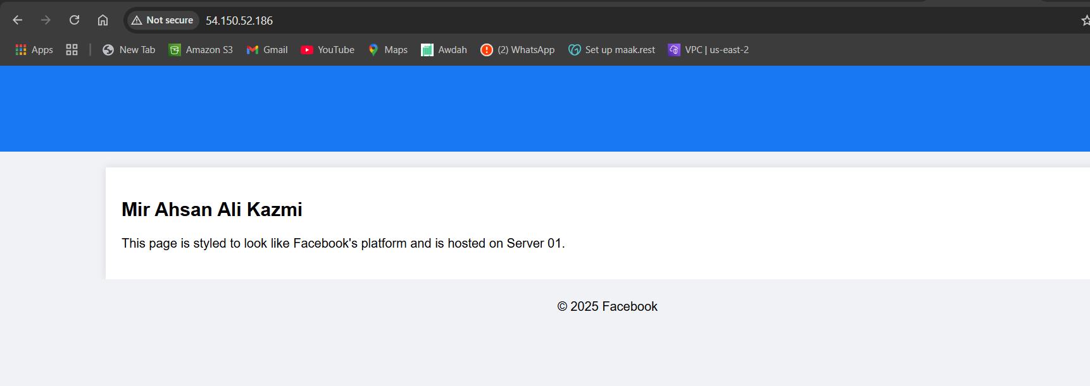

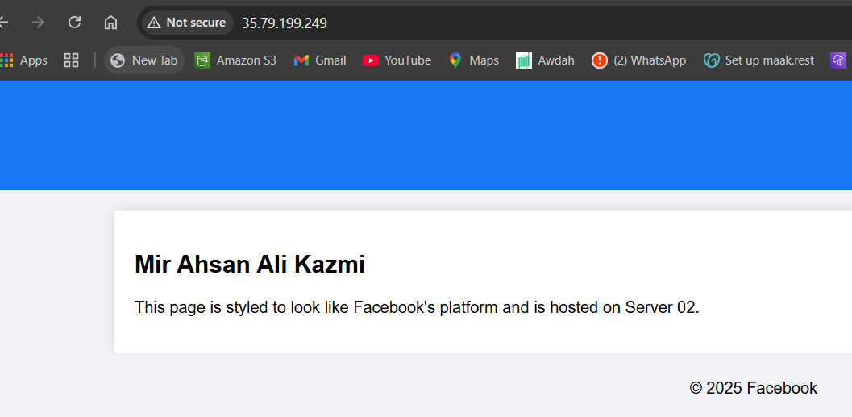

1. Attach SSL for application load balancer.*

Ssl certificate created

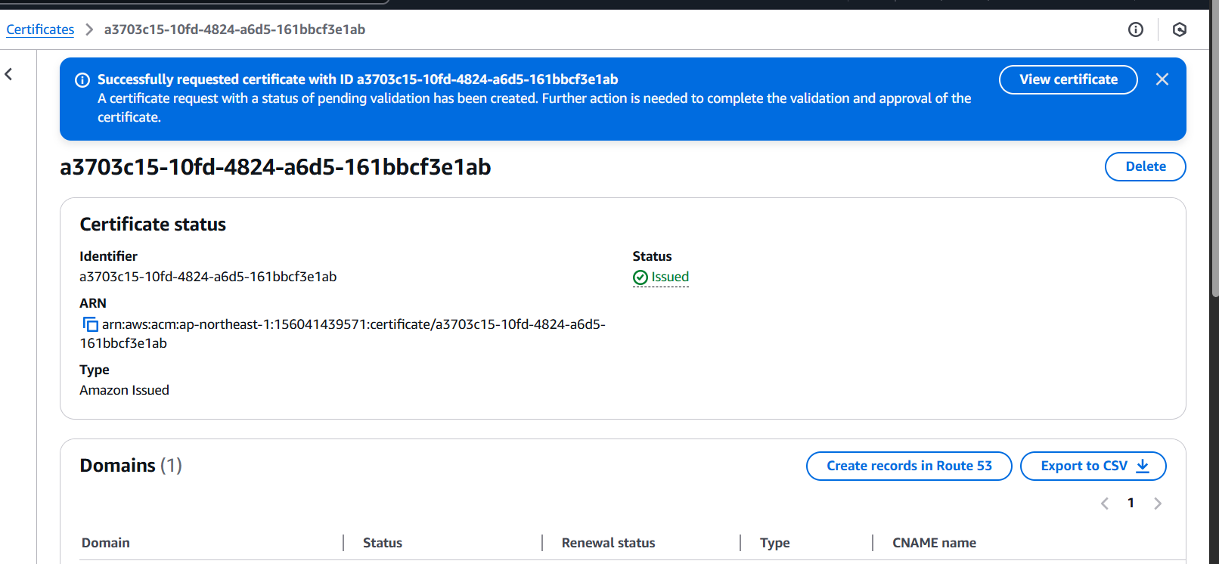

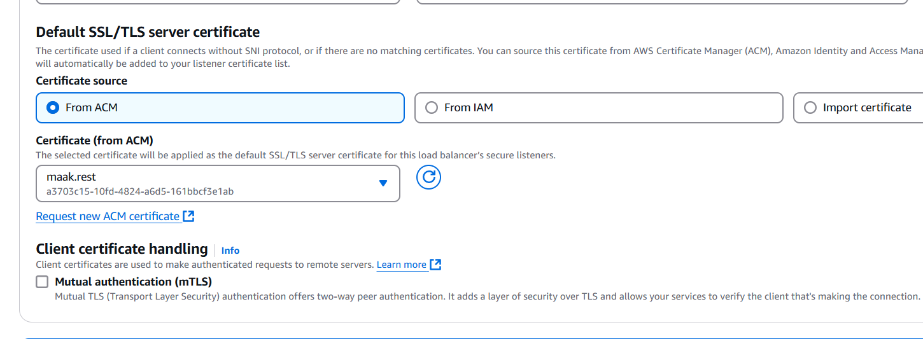

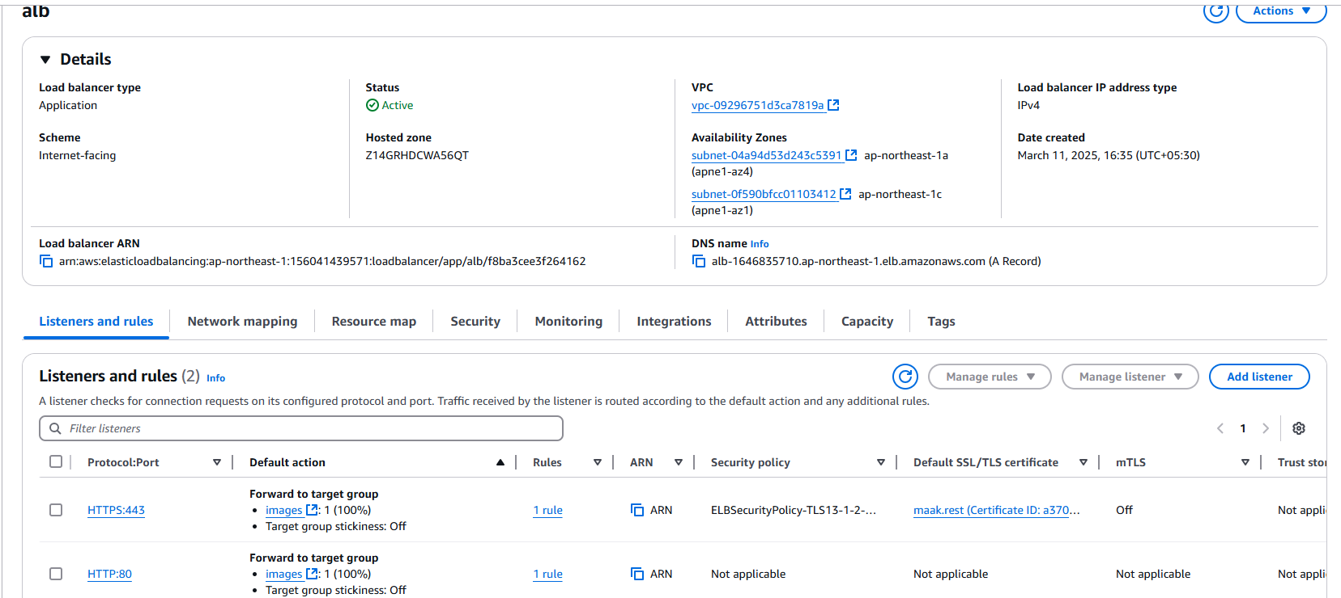

1. Map Applciation load balancer to R53.*

Step 1 Step1: Mapped Application load balancer to R53

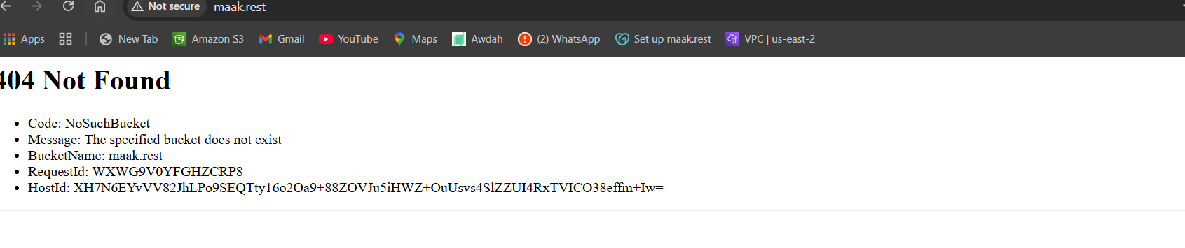 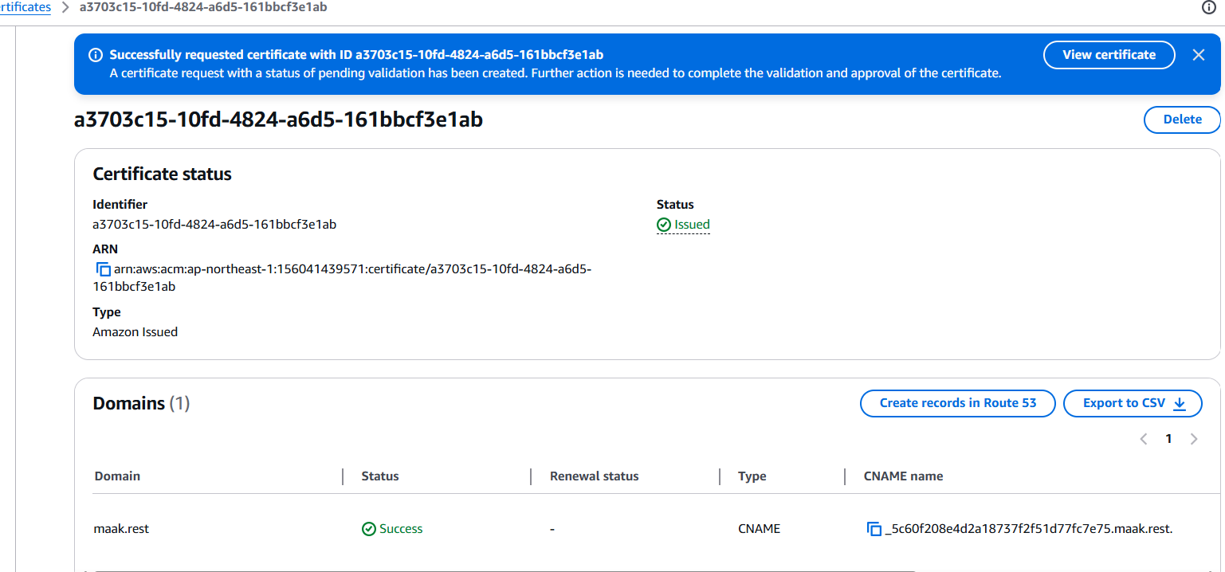

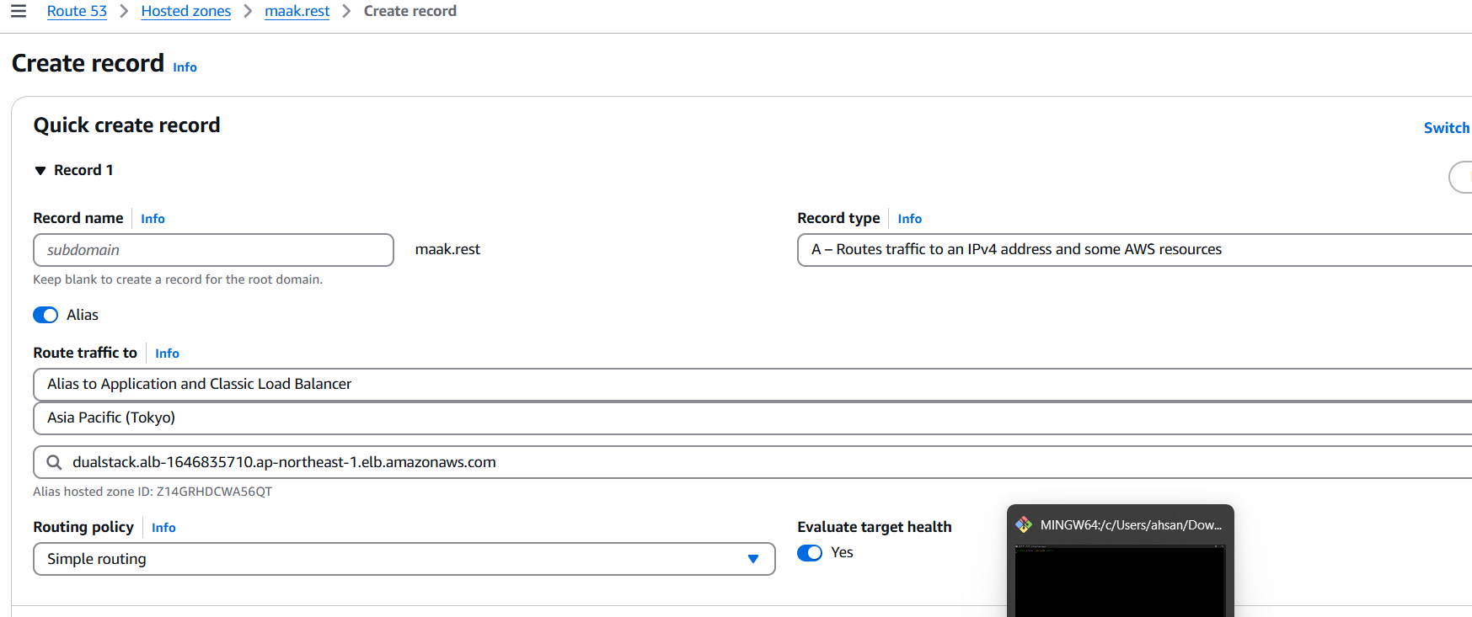

6) Push the application load balancer logs to s3.*